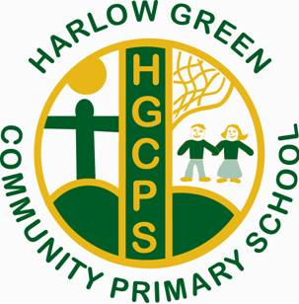
Harlow Green Community Primary School
Minutes from PTA Meeting
Wednesday 12th September at 2:30pm
Thank you to those who attended with Mrs Chapman.
The following items were discussed:
Events planned for Autumn term 2018
- McMillan Coffee and cake afternoon Friday 28th September at 2pm
- Children in Need bake sale 2pm on Friday 16th November
- Christmas raffle (tickets to be sold at Christmas performances)
People’s Kitchen
We will be collecting donations for the People’s Kitchen in January this year as we feel this is a vital time to support families in need.
Nursery refurbishment
A big thank you to the whole school community who have organised and supported our school with past events. The money raised has helped us to refurbish our school nursery. (These are shown on our school website).
Local Charities
In addition to supporting nationwide charities, our PTA would also like to raise money for local charities. Our School Council will be involved in making a decision over which charity to support.
Nearly New Uniform
We will continue to collect and sell the uniform that has been donated at various events throughout the year.
More PTA volunteers …
And finally, the PTA would welcome more parents and grandparents to support and raise money for school. Another meeting will be organised after October half term.

